Closa Care Plan Engine: Developer Spec
Oct 10, 2026 · @Ade
A free intake for women in Nigeria: 13 core questions and up to 7 follow-ups produce a personalised care plan. The plan is built by a deterministic rules engine and assembled from pre-written content. There are no AI or LLM calls at runtime.

1. How it works
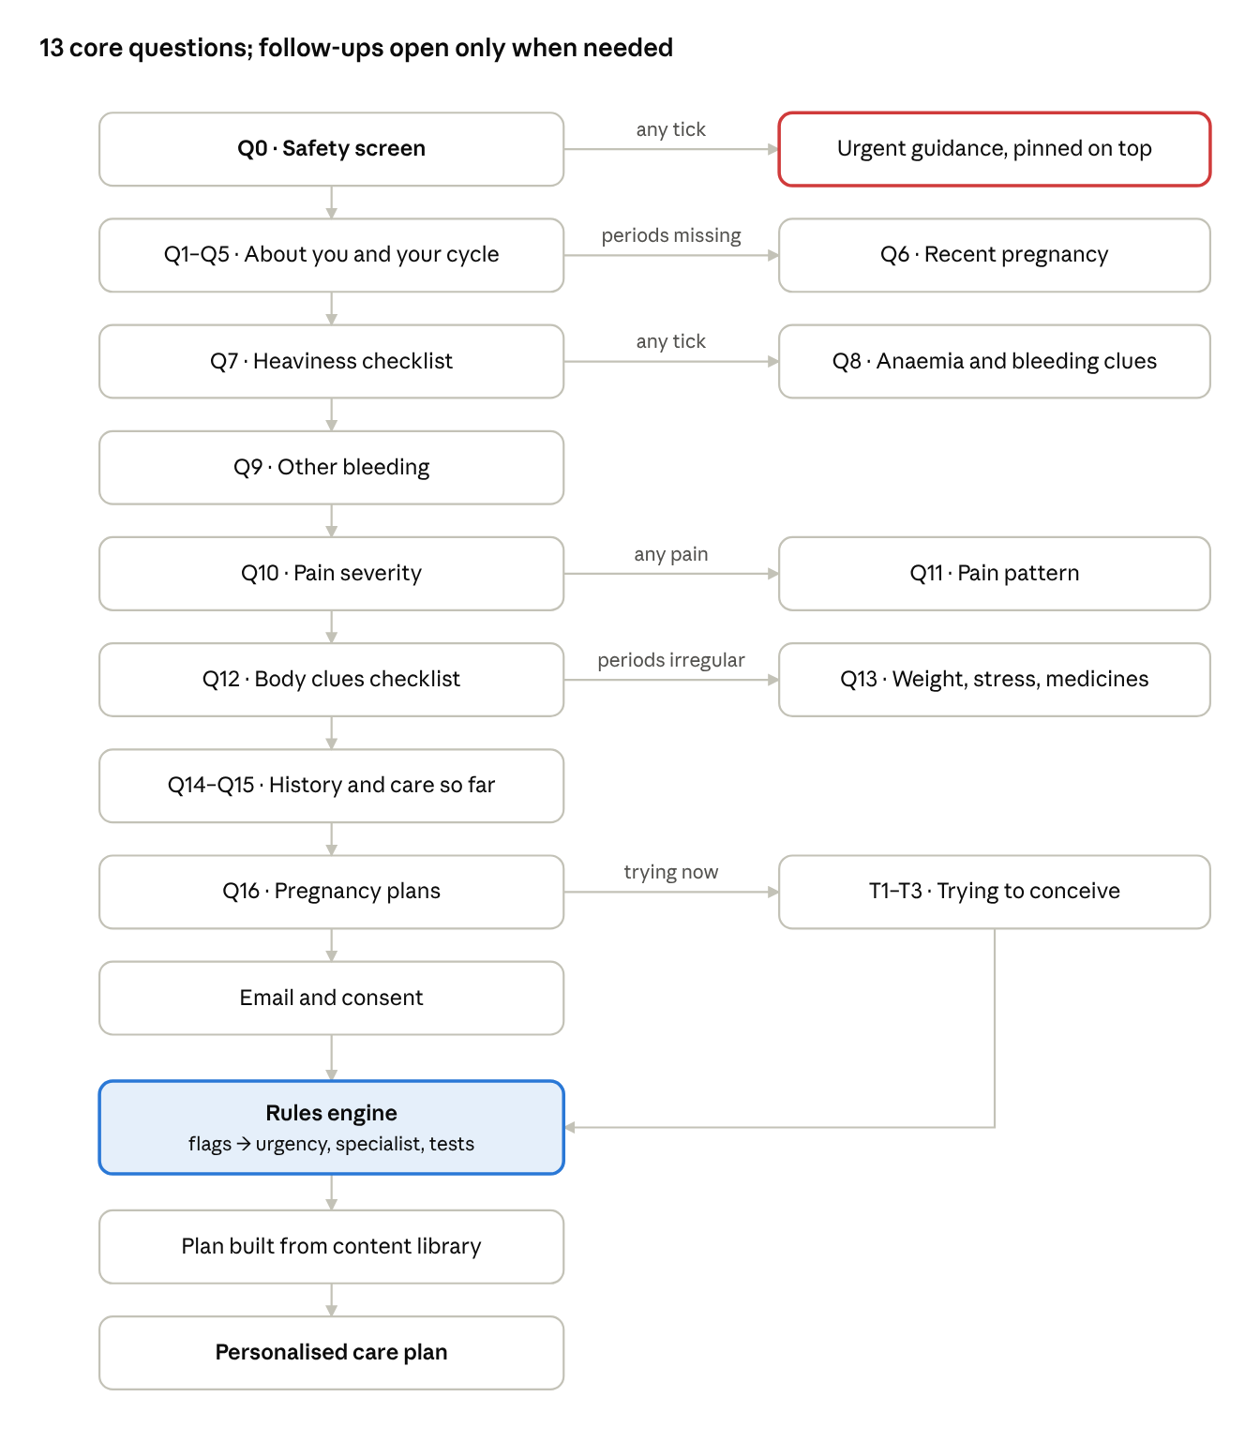
intake flow · 13 core questions, up to 7 follow-ups, no AI at runtime
- Collect answers. Q0 runs first; any emergency option shows the emergency screen immediately.
- Evaluate flags. Each flag stores the option codes that triggered it. These are its evidence, used later in the plan's wording.
- Apply rules. Urgency (highest level wins), specialists, tests and trying-to-conceive rules.
- Assemble the plan. Fixed text from the content library for each flag, rule and urgency level, with the labels of her own answers inserted where a template asks for them.
Clinical thresholds live in a config file, not in code (Section 9), so the clinical team can change them without a release.

2. Questions
One question per screen. Multi-select questions have a none option that clears the others. Labels are user-facing text; codes are what the engine reads.

Q0: Safety screen (always first, multi)
"Do any of these apply to you right now?" Any code except none shows the emergency screen for that code before continuing. The user may then continue; the urgent message stays pinned at the top of her plan.
Code | Label
s1_heavy_faint | I'm soaking a pad every hour for 2 hours or more, or I feel faint or very short of breath
s2_sudden_pain | Sudden, severe pain low in my belly or on one side
s3_preg_symptoms | I might be pregnant and have pain, bleeding, dizziness or pain at the tip of my shoulder
s4_post_pregnancy | I gave birth, miscarried or ended a pregnancy in the last 6 weeks, and have a fever, smelly discharge or worsening pain
s5_postmeno_bleed | I've had bleeding after my periods stopped for good (12 months or more)
none | None of these

Q1–Q16 and T1–T3
ID | Question | Type | Options (code: label) | Show if
Q1 | What's bothering you most? | multi | pain: Painful periods · heavy: Heavy periods · irregular: Irregular or missed periods · other_bleeding: Bleeding between periods or after sex · ttc: Trying to get pregnant | always
Q2 | How old are you? | single | lt16: Under 16 · 16_19 · 20_34 · 35_39 · 40_44 · 45_54 · 55p: 55+ | always
Q3 | Could you be pregnant? | single | yes · no · unsure: Not sure · not_active: I'm not having sex | always
Q4 | What contraception do you use? | single | none · hormonal: Pill, injection, implant or hormonal coil · copper_iud: Copper coil · non_hormonal: Condoms or other | always
Q5 | How often do your periods come? | single | regular: Every 24–38 days · frequent: More often than every 24 days · infrequent: Less often than every 38 days · unpredictable: Changes a lot · none_3m: No period for 3 months or more · never: I've never had a period · menopause: They've stopped for good | always
Q6 | In the past 12 months, have you given birth, miscarried or ended a pregnancy? | single | no · yes_bf: Yes, and I'm breastfeeding · yes_not_bf: Yes, not breastfeeding · prefer_not | Q5 in [infrequent, unpredictable, none_3m]
Q7 | Which of these happen with your periods? | multi | change_1_2h: I change my pad every 1–2 hours on heavy days · clots: Clots bigger than a bottle cap · gt8_days: Bleeding lasts more than 8 days · flooding: I leak onto clothes or bedding, or change at night · none | always
Q8 | Do you have any of these? | multi | fatigue: Very tired or breathless on stairs · dizzy: Dizzy or heart racing · pica: Craving ice, chalk or clay · since_first_period: Heavy since my very first period · bruising: I bruise easily, get nosebleeds, or bled heavily after a tooth removal or birth · none | Q7 ≠ [none] or Q1 has heavy
Q9 | Do you bleed at other times? | multi | between: Between periods · after_sex: After sex · none: Neither | always
Q10 | How bad is your period or pelvic pain at its worst? | single | none · mild · moderate · severe | always
Q11 | Which of these describe your pain? | multi | worsening: Got worse over the years · painkillers_fail: Painkillers don't help much · disabling: Makes me miss work or school, vomit or faint · non_cyclic: There most of the month · deep_sex_pain: Deep pain during sex · bowel_bladder: Pain opening my bowels or passing urine during my period · none | Q10 ≠ none
Q12 | Have you noticed any of these? | multi | hair_acne: Extra hair on face, chest or belly, or hard-to-treat acne · dark_skin: Dark, velvety skin on neck or armpits · weight_change: Big weight change without trying · bulk: Swollen belly, a lump, or passing urine very often · hot_flushes: Hot flushes or night sweats · thyroid_sx: Too hot or cold, racing heart or shaky hands · nipple_milk: Milky fluid from nipples (not breastfeeding) · discharge: Unusual discharge or burning when passing urine · fever_pain: Fever with pelvic pain · none | always
Q13 | Do any of these apply? | multi | diet_weight_loss: Lost a lot of weight through dieting or exercise · hard_training: I train hard most days · stress: Major stress · headache_vision: Frequent headaches or changes in vision · mental_health_meds: I take medicine for mental health · none | Q5 in [infrequent, unpredictable, none_3m, never]
Q14 | Has a doctor ever told you that you have any of these? | multi | fibroids · endometriosis · pcos · thyroid · sickle_cell: Sickle cell disease · pid_sti: Pelvic infection or STI · none | always
Q15 | Have you already… | multi | had_scan: Had a scan for this · had_bloods: Had blood tests for this · told_normal: Been told it's normal · treatment_failed: Tried treatment that didn't help · many_visits: Seen doctors several times without a clear answer · none | always
Q16 | Are you trying to get pregnant, or planning to? | single | trying_now · within_12m: In the next 12 months · later: Later in life · not_planning: Not planning or not sure | always
T1 | How long have you been trying? | single | lt6m: Under 6 months · 6_11m · gte12m: 12 months or more | Q16 = trying_now
T2 | Has your partner had a semen test? | single | normal: Yes, normal · abnormal: Yes, something was found · not_done: No · na: Doesn't apply | Q16 = trying_now
T3 | Have you had either of these? | multi | miscarriage_2plus: 2 or more miscarriages · ectopic: An ectopic pregnancy · none: Neither | Q16 = trying_now
After the last question: email and consent screen, then the plan.

3. Flags
Each flag is a boolean plus an evidence list: the question/option codes that made the condition true. Evidence drives the "You told us…" wording in the plan. "Has any" means at least one of the listed codes was selected. Priority sets the order of clinical flags in the plan (1 = shown first).

Clinical flags
Flag | Condition | Priority
F-PREG | Q3 in [yes, unsure] | 1
F-ENDOMRISK | (Q2 in [45_54, 55p] and (F-IMB or F-HMB)) or (F-PCOS and F-AMEN) | 2
F-PCB | Q9 has after_sex | 3
F-INFECT | Q12 has any [discharge, fever_pain] or (Q14 has pid_sti and Q10 ≠ none) | 4
F-ANAEMIA | Q8 has any [fatigue, dizzy, pica] | 5
F-BLEEDDIS | F-HMB and Q8 has any [since_first_period, bruising] | 6
F-FIBROID | F-HMB and (F-BULK or Q14 has fibroids) | 7
F-ENDO | Q11 has any [deep_sex_pain, bowel_bladder] or (F-SECDYSM and Q14 has endometriosis) | 8
F-ADENO | F-HMB and F-SECDYSM and Q2 in [35_39 or older] | 9
F-SECDYSM | Q10 = severe or Q11 has any [worsening, painkillers_fail, disabling, non_cyclic] | 10
F-HMB | Q7 has any [change_1_2h, clots, gt8_days, flooding] | 11
F-BULK | Q12 has bulk | 12
F-IMB | Q9 has between | 13
F-POI | (F-AMEN or F-OLIGO) and Q12 has hot_flushes and Q2 below 40_44 | 14
F-PRIMAMEN | Q5 = never and Q2 ≠ lt16 | 15
F-AMEN | Q5 = none_3m and not F-POSTPARTUM | 16
F-ASHERMAN | Q6 = yes_not_bf and Q5 = none_3m | 17
F-PRL | (F-OLIGO or F-AMEN) and (Q12 has nipple_milk or Q13 has any [headache_vision, mental_health_meds]) | 18
F-PCOS | (F-OLIGO or F-AMEN) and (Q12 has any [hair_acne, dark_skin, weight_change] or Q14 has pcos) | 19
F-THY | (Q12 has thyroid_sx or Q14 has thyroid) and (F-HMB or F-IMB or F-OLIGO or F-FREQ or F-AMEN) | 20
F-HYPO | (F-AMEN or F-OLIGO) and Q13 has any [diet_weight_loss, hard_training, stress] | 21
F-PERI | Q2 in [40_44 or older] and (F-OLIGO or F-FREQ or Q12 has hot_flushes) | 22
F-OLIGO | Q5 in [infrequent, unpredictable] | 23
F-FREQ | Q5 = frequent | 24
F-CONTRA | Q4 = hormonal and (F-IMB or Q5 in [unpredictable, none_3m]) | 25
F-PRIMDYSM | Q10 in [mild, moderate] and Q11 = [none] | 26
F-POSTPARTUM | Q6 = yes_bf | 27
When a more specific flag is set, its general parent is not shown as a separate possibility in the plan: F-FIBROID or F-ADENO hides F-HMB, and F-ENDO or F-ADENO hides F-SECDYSM. The parent still counts for rules.

Modifier flags
These change wording or add a note; they are never listed as possibilities.
Flag | Condition | Effect
F-SICKLE | Q14 has sickle_cell | Adds the sickle cell note; haematology added to specialists
F-NORMALISED | Q15 has told_normal and (F-HMB or F-SECDYSM or F-ANAEMIA) | Adds the validation note
F-ROUNDS | Q15 has many_visits | Uses specialist first stop (rule SP20)
F-DONE | Q15 has any [had_scan, had_bloods] | Adds "bring your previous reports"
F-IMPACT | Q10 = severe or Q11 has disabling | Raises U5 to U4
F-FERTGOAL | Q16 in [trying_now, within_12m, later] | Uses the fertility-aware text variant of flag content
F-TTC | Q16 in [trying_now, within_12m] | Adds the trying-to-conceive section

4. Urgency
Evaluate every rule; the plan shows the single highest level triggered (U1 highest).
Level | Label shown | Content key
U1 | Get emergency care now (call 112 or go to the nearest hospital emergency unit) | urgency.U1.{q0_code}
U2 | See a doctor in the next 1–2 days | urgency.U2
U3 | Book an appointment within 2 weeks | urgency.U3
U4 | Book an appointment within 4–6 weeks | urgency.U4
U5 | Book a routine appointment | urgency.U5

Rule | Level | Condition
U1-a | U1 | Q0 has any of s1_heavy_faint, s2_sudden_pain, s3_preg_symptoms, s4_post_pregnancy
U2-a | U2 | Q12 has fever_pain
U2-b | U2 | F-HMB and Q8 has dizzy
U3-a | U3 | Q0 has s5_postmeno_bleed
U3-b | U3 | F-PCB or F-ENDOMRISK
U3-c | U3 | F-PRL and Q13 has headache_vision
U3-d | U3 | F-BULK and (Q2 in [45_54, 55p] or Q12 has weight_change)
U4-a | U4 | Any of F-HMB, F-FIBROID, F-ADENO, F-SECDYSM, F-ENDO, F-BLEEDDIS, F-IMB, F-AMEN, F-POI, F-PRIMAMEN, F-ASHERMAN, F-ANAEMIA, F-INFECT
U5-a | U5 | Any of F-PCOS, F-OLIGO, F-FREQ, F-THY, F-PERI, F-HYPO, F-PRIMDYSM, F-CONTRA
U5-b | U5 | No clinical flag set → content key urgency.U5.reassure
Modifiers, applied after the rules:
- F-IMPACT raises U5 to U4.
- F-POSTPARTUM with no other clinical flag → U5 with urgency.U5.postpartum.
- F-PREG with no U1 → keep the level, and show the pregnancy-test block first (Section 8).

5. Who to see
Each triggered rule outputs a first stop and, where listed, the specialist to ask for. Order outputs by the urgency level of the triggering flag, then flag priority. Merge outputs with the same first stop. Show at most MAX_SPECIALISTS (config). Content key: specialist.{rule}.
Rule | Condition | First stop | Specialist to ask for
SP1 | U1 | Nearest hospital emergency unit | —
SP2 | F-INFECT | Hospital or clinic with a laboratory for infection tests | Gynaecologist if pain continues after treatment
SP3 | F-HMB or F-ANAEMIA, and no F-FIBROID, F-ADENO or F-BULK | GP or general hospital doctor for first blood tests | Gynaecologist if bleeding continues or treatment doesn't help
SP4 | F-FIBROID or F-BULK | Gynaecologist | One experienced in fibroid surgery; with F-FERTGOAL, one who offers fertility-sparing options (myomectomy)
SP5 | F-ENDO, or F-SECDYSM and Q11 has painkillers_fail | Gynaecologist | One who does laparoscopic (keyhole) surgery and treats endometriosis
SP6 | F-ADENO | Gynaecologist | Ask for a pelvic scan by an experienced sonographer
SP7 | F-BLEEDDIS | GP for first blood tests | Haematologist
SP8 | F-SICKLE and any clinical flag | Her usual sickle cell clinic | Gynaecologist working with her haematologist
SP9 | F-PCOS | GP for first blood tests | Gynaecologist or endocrinologist; fertility specialist if F-TTC
SP10 | F-THY | GP for thyroid test | Endocrinologist if the result is abnormal
SP11 | F-PRL | GP for prolactin test | Endocrinologist if raised
SP12 | F-POI | Gynaecologist | Fertility specialist promptly if F-FERTGOAL
SP13 | F-PERI | GP | Gynaecologist if symptoms are hard to manage
SP14 | F-HYPO | GP | Gynaecologist if periods don't return
SP15 | F-PCB | Gynaecologist or GP for a cervix examination | —
SP16 | Q0 has s5_postmeno_bleed, or F-ENDOMRISK | Gynaecologist | —
SP17 | F-CONTRA | Family planning clinic or whoever gave her the contraception | —
SP18 | F-PRIMAMEN | Gynaecologist | —
SP19 | F-ASHERMAN | Gynaecologist | One who performs hysteroscopy
SP20 | F-ROUNDS | Replaces any GP first stop with a gynaecologist | Consultant gynaecologist (teaching or specialist hospital)
SP21 | F-PRIMDYSM only | Pharmacist or GP | Gynaecologist if no better after 3 months

6. Tests to ask for
Collect every test whose condition is true, remove duplicates, and list them in table order. Content key: test.{id} (name + timing text).
Test | Name shown | Condition | Timing text
T-PREG | Pregnancy test | F-PREG or F-AMEN or F-OLIGO, unless Q3 = not_active | Do this first
T-FBC | Full blood count | F-HMB or F-ANAEMIA | Any day
T-FERR | Iron level (ferritin) | F-HMB or F-ANAEMIA | Any day
T-TFT | Thyroid test (TSH) | F-THY or F-OLIGO or F-AMEN or F-FREQ or F-POI | Any day
T-PRL | Prolactin | F-AMEN or F-OLIGO or F-PRL | Morning, rested
T-FSH | FSH, LH and oestradiol | F-AMEN or F-OLIGO or F-POI | Day 2–5 of a period, or any day if no periods
T-ANDRO | Testosterone | F-PCOS | Day 2–5, or any day if no periods
T-METAB | Blood sugar (HbA1c) and blood pressure | F-PCOS | Any day
T-PROG | Progesterone (checks ovulation) | F-TTC and (F-OLIGO or F-PCOS) | About 7 days before the next expected period
T-USS | Pelvic scan (transvaginal preferred) | Any of F-FIBROID, F-BULK, F-ADENO, F-SECDYSM, F-ENDO, F-IMB, F-AMEN, F-PCOS, F-ASHERMAN, F-ENDOMRISK, or Q0 has s5_postmeno_bleed | Just after a period ends. Ask for the written report
T-STI | Infection tests (chlamydia, gonorrhoea, HIV, syphilis, vaginal swab) | F-INFECT or F-IMB or F-PCB | Any day
T-EXAM | Examination of the cervix | F-PCB or F-IMB or F-INFECT | Not during heavy bleeding
T-CERV | Cervical screening | F-PCB or F-IMB, and Q2 ≥ CERV_MIN_AGE (config) | Mid-cycle
T-COAG | Clotting tests | F-BLEEDDIS | Any day
T-GENO | Genotype | F-TTC or F-ANAEMIA, unless Q14 has sickle_cell | Any day
Specialist-may-suggest list (shown under its own heading, not as tests to request):
Item | Condition
Womb lining sample or hysteroscopy | F-ENDOMRISK or Q0 has s5_postmeno_bleed
Pelvic MRI | F-ADENO or F-ENDO
Laparoscopy | F-ENDO
List logic:
- F-PREG: T-PREG is shown first with test.preg_gate. Hormone tests (T-TFT, T-PRL, T-FSH, T-ANDRO, T-PROG) get the note test.after_negative_preg.
- Q4 = hormonal: T-FSH, T-ANDRO and T-PROG get the note test.on_hormonal_contraception.
- F-DONE: show test.bring_reports above the list.
- T-USS with F-ENDO: always append test.normal_scan_endo (a normal scan does not rule out endometriosis).

7. Trying to conceive
Runs only when F-TTC is set. Outputs fill the plan's trying-to-conceive section. Content key: ttc.{rule}.
Rule | Condition | Output
TTC-1 | T1 = gte12m and Q2 below 35_39 | "Time to get checked" + both partners' first tests
TTC-2 | T1 in [6_11m, gte12m] and Q2 = 35_39 | "Time to get checked" + both partners' first tests
TTC-3 | Q16 = trying_now and any of: Q2 ≥ 40_44; F-OLIGO, F-AMEN, F-PCOS, F-ENDO, F-FIBROID, F-POI, F-SICKLE; Q14 has pid_sti; T3 has ectopic; T2 = abnormal | "Get checked now, don't wait" + both partners' first tests. Add fertility specialist to Who to see if F-POI or Q2 ≥ 40_44
TTC-4 | T3 has miscarriage_2plus | Miscarriage assessment with a gynaecologist + support text
TTC-5 | Q16 = trying_now and T2 = not_done | Partner's semen test now, alongside her tests
TTC-6 | F-TTC | Preconception basics: folic acid, medicines review, both partners know their genotype
TTC-7 | TTC-1, TTC-2 or TTC-3 | Add to tests: T-PROG, T-FSH, T-TFT, T-STI, rubella immunity, T-USS, T-GENO; partner semen analysis. HSG listed under "specialist may suggest"
Fixed constraints:
- Never recommend AMH testing or IVF as a next step.
- Partner semen analysis appears whenever TTC-1, 2, 3 or 5 fires, unless T2 = na.
- Q6 = yes_not_bf/yes_bf or T3 has any code other than `none` adds ttc.loss_support text.
- TTC status is stored only with its own separate consent and never used for marketing.

8. Care plan assembly
The plan is built only from content-library strings selected by the rules, with her own answers inserted. Nothing is generated at runtime.

Answer phrasing
Every option code has three strings, so her answers can be reused in the plan:
Field | Used in | Example for Q7.clots
label | The question screen | Clots bigger than a bottle cap
you | "You told us…" lines in the plan | you pass clots bigger than a bottle cap
clinical | Doctor summary | clots >2.5 cm

Plan sections, in order
# | Section | Shown when | Built from
1 | Emergency banner | U1 | urgency.U1.{q0_code} for each Q0 code selected
2 | How soon to be seen | Always | urgency.{level}
3 | Take a pregnancy test first | F-PREG | plan.preg_first
4 | What your answers may point to | Any clinical flag except F-PREG, F-POSTPARTUM | Top MAX_POSSIBILITIES flags by priority, after hiding parents (Section 3). Each item: flag.{id}.title, flag.{id}.body (or flag.{id}.body_fert if F-FERTGOAL), then the evidence line. If no clinical flag: plan.reassure
5 | Notes | Modifier flags | note.normalised, note.sickle, note.rounds, note.postpartum
6 | Who to see | Always | Section 5 outputs
7 | Tests to ask for | Any test | Section 6 outputs
8 | Questions to ask your doctor | Always | questions.{flag} for the first 2 flags in section 4 + questions.generic
9 | Warning signs | Always | warning.{flag} for each flag in section 4, de-duplicated, max MAX_WARNINGS, + warning.generic
10 | What you can do now | Any flag in section 4 | selfcare.{flag} for each flag in section 4, de-duplicated
11 | Trying to conceive | F-TTC | Section 7 outputs
12 | Summary for your doctor | Always | Doctor summary template below
13 | Footer | Always | plan.disclaimer (guidance, not a diagnosis)

Evidence line
Template: Why we suggest this: {evidence}. where {evidence} is the you strings of the flag's evidence codes, joined with ", " and "and" before the last. If a flag's evidence includes other flags, use their evidence codes.
Example: F-ENDO with evidence [Q11.worsening, Q11.deep_sex_pain] → "Why we suggest this: your pain has got worse over the years and you have deep pain during sex."

Doctor summary template
One paragraph built from clinical strings. Skip any part whose answer is empty or none.
{Q2} woman. Main concerns: {Q1}. Periods: {Q5}. Bleeding: {Q7}; {Q9}. Pain: {Q10}; {Q11}. Other symptoms: {Q8}; {Q12}; {Q13}. Known conditions: {Q14}. Contraception: {Q4}. Previous care: {Q15}. Pregnancy plans: {Q16}; trying for {T1}.
Example: "Age 20–34 woman. Main concerns: heavy, painful periods. Periods: regular. Bleeding: pad change every 1–2 h, clots >2.5 cm. Pain: severe; worsening over years, deep dyspareunia. Other symptoms: fatigue. Previous care: told symptoms normal. Pregnancy plans: within 12 months."

Delivery
Show the plan as a web page and email the same content to the address given. Section 12 must be easy to copy or print on its own.

9. Config, upload, data and edge cases

Config values
Read these from config, not hard-coded. Defaults await clinical sign-off.
Key | Default | Used by
MAX_POSSIBILITIES | 4 | Plan section 4
MAX_SPECIALISTS | 3 | Section 5
MAX_WARNINGS | 5 | Plan section 9
EMERGENCY_NUMBER | 112 | U1 content
CERV_MIN_AGE | 25 | T-CERV
ADENO_MIN_AGE_BAND | 35_39 | F-ADENO
PERI_MIN_AGE_BAND | 40_44 | F-PERI
ENDOMRISK_MIN_AGE_BAND | 45_54 | F-ENDOMRISK
POI_MAX_AGE_BAND | 35_39 | F-POI
TTC_WAIT_UNDER_35 | gte12m | TTC-1
TTC_WAIT_35_39 | 6_11m | TTC-2
TTC_NO_WAIT_AGE_BAND | 40_44 | TTC-3

Cycle-app upload (optional, before Q5)
- Accept CSV exports from supported apps only; parse with a fixed parser per app. No PDF or screenshot reading in v1.
- From the last 6 months of period start dates, suggest a Q5 code: last start over 90 days ago → none_3m; median gap < 24 → frequent; median gap > 38 → infrequent; longest minus shortest gap > 7 days → unpredictable; otherwise regular.
- If spotting is logged outside period days, pre-tick Q9 between.
- Show the suggestion for her to confirm or change. Fewer than 3 logged cycles → no suggestion.
- Delete the file after parsing.

Data
- Email and consent are collected before the plan is shown.
- Store answers, flags with evidence, urgency, plan content and the content-library version used.
- Log any Q0 emergency selection as a safety event.
- TTC answers need a separate consent tick; without it, use them for the plan but don't store them.

Edge cases
- Q2 = lt16: use the u16 content variants (wording to come from the clinical team). Emergency logic is unchanged.
- Q5 = menopause: no cycle flags; S5 in Q0 covers bleeding.
- Several Q0 codes: show one banner per code.
- No clinical flags: U5 with plan.reassure; sections 6–9 use generic content.
- F-HYPO content: must not contain weights, calorie numbers or exercise targets.

